COS20019

Cloud Computing Architechture

Truong Ngoc Gia Hieu

105565520

Week 2 – ACF Lab 3 Report  
Introduction to EC2

**Lab 3: Introduction to Amazon EC2**

**A. Lab overview and objectives**

This lab provides you with a basic overview of launching, resizing, managing, and monitoring an Amazon EC2 instance.

**Amazon Elastic Compute Cloud (Amazon EC2)** is a web service that provides resizable compute capacity in the cloud. It is designed to make web-scale cloud computing easier for developers.

Amazon EC2's simple web service interface allows you to obtain and configure capacity with minimal friction. It provides you with complete control of your computing resources and lets you run on Amazon's proven computing environment. Amazon EC2 reduces the time required to obtain and boot new server instances to minutes, allowing you to quickly scale capacity, both up and down, as your computing requirements change.

Amazon EC2 changes the economics of computing by allowing you to pay only for capacity that you actually use. Amazon EC2 provides developers the tools to build failure resilient applications and isolate themselves from common failure scenarios.

After completing this lab, you should be able to do the following:

* Launch a web server with termination protection enabled
* Monitor Your EC2 instance
* Modify the security group that your web server is using to allow HTTP access
* Resize your Amazon EC2 instance to scale and enable stop protection
* Explore EC2 limits
* Test stop protection
* Stop your EC2 instance

**Duration**

This lab takes approximately **35 minutes** to complete.

**AWS service restrictions**

In this lab environment, access to AWS services and service actions might be restricted to the ones that are needed to complete the lab instructions. You might encounter errors if you attempt to access other services or perform actions beyond the ones that are described in this lab.

**Accessing the AWS Management Console**

1. At the top of these instructions, choose **Start Lab**.

* The lab session starts.
* A timer displays at the top of the page and shows the time remaining in the session.



* Before you continue, wait until the circle icon to the right of the AWS link in the upper-left corner turns green.

***Figure 1: Lab Started***

2. To connect to the AWS Management Console, choose the AWS link in the upper-left corner.

* A new browser tab opens and connects you to the console.

***Figure 2: AWS Management Console***

3. Arrange the AWS Management Console tab so that it displays along side these instructions. Ideally, you will be able to see both browser tabs at the same time, to make it easier to follow the lab steps.

**Getting Credit for your work**

At the end of this lab you will be instructed to submit the lab to receive a score based on your progress.



**B. Tasks**

**Task 1: Launch Your Amazon EC2 Instance**

In this task, you will launch an Amazon EC2 instance with *termination protection* and *stop protection*. Termination protection prevents you from accidentally terminating the EC2 instance and stop protection prevents you from accidentally stopping the EC2 instance. You will also specify a User Data script when you launch the instance that will deploy a simple web server

4. In the **AWS Management Console** choose **Services**, choose **Compute** and then choose **EC2**.

**Note**: Verify that your EC2 console is currently managing resources in the **N. Virginia** (us-east-1) region. You can verify this by looking at the drop down menu at the top of the screen, to the left of your username. If it does not already indicate N. Virginia, choose the N. Virginia region from the region menu before proceeding to the next step.

***Figure 3: EC2 Dashboard***

***Figure 4: Launch Instance page***

***Step 1: Name and tags***

***Figure 5: Set the instance name***

**Step 2: Application and OS Images (Amazon Machine Image)**

7. In the list of available Quick Start AMIs, keep the default Amazon Linux AMI selected.

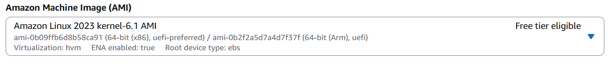***Figure 6: Quick Start Selection***

***Figure 7: AMI Amazon Linux version***

**Step 3: Instance type**

***Figure 8: instance type selection***

**Step 4: Key pair (login)**

***Figure 9: Key pair (login) selection***

**Step 5: Network settings**

11. Next to Network settings, choose **Edit.**

***Figure 10: VPC and Subnet selection***

***Figure 11: Firewall configuration***

**Step 6: Configure storage**

**Step 7: Advanced details**



***Figure 12: Enable Terminal Protection***

17. Scroll to the bottom of the page and then copy and paste the code shown below into the **User data** box:

***Figure 13: User data configuration***

🛈When you launch an instance, you can pass user data to the instance that can be used to perform automated installation and configuration tasks after the instance starts.

Your instance is running Amazon Linux 2023. The shell script you have specified will run as the root guest OS user when the instance starts. The script will:

* Install an Apache web server (httpd)
* Configure the web server to automatically start on boot
* Run the Web server once it has finished installing
* Create a simple web page

**Step 8: Launch the instance**

***Figure 13: Launch instance successfully***

***Figure 14: Launch the seb server successfully***

***Task 2: Monitor Your Instance***

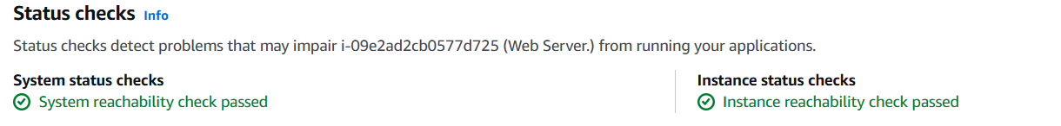Monitoring is an important part of maintaining the reliability, availability, and performance of your Amazon Elastic Compute Cloud (Amazon EC2) instances and your AWS solutions.

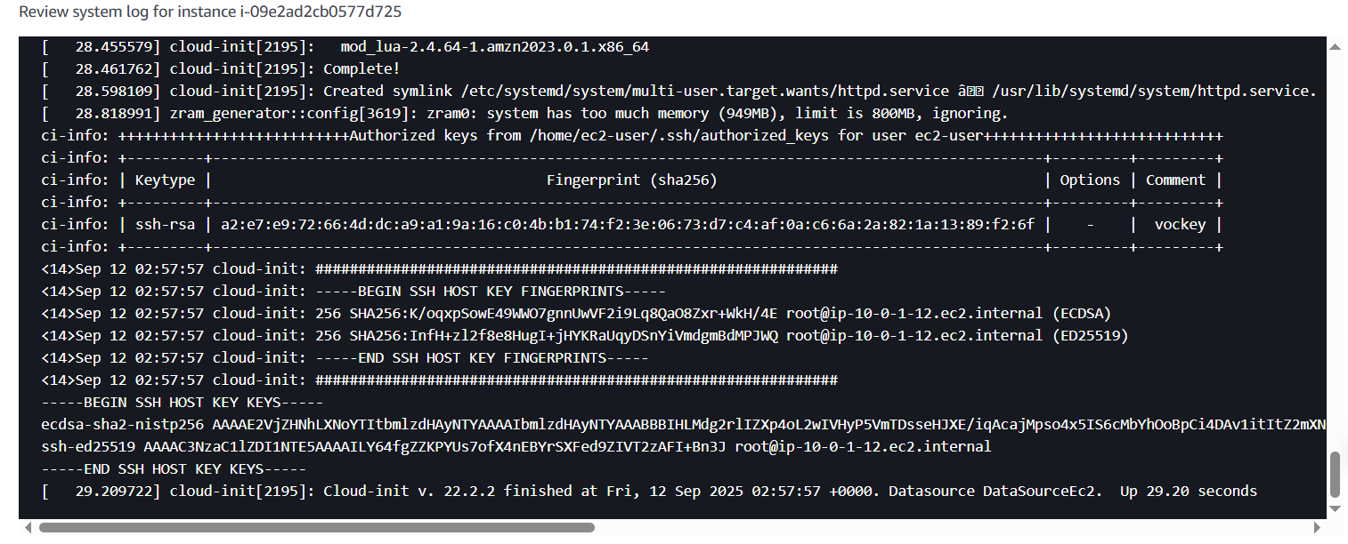***Figure 15: Status Check***

***Figure 16: System Console Window***

25. Choose **Cancel.**

**Task 3: Update Your Security Group and Access the Web Server**

28. Ensure **Web Server** is still selected. Choose the **Details** tab

***Figure 17: Web Server Selected***

29. Copy the ***Public IPv4 address*** of your instance to your clipboard.

From my perspective, I’m currently unable to access the web server because the security group is not permitting inbound traffic on port 80,, which is used for HTTP web requests. As a result, this is demostrate of using a security group as a firewall to restrict the network traffic and allowed in and out of instance

1. Keep the browser tab open, but return to the **EC2 Console** tab.

1. A screenshot of a computer

   AI-generated content may be incorrect.In the left navigation pane, choose **Security Groups**.

***Figure 18: Security groups***

***Figure 19: Wen Server Security group selected***

1. Choose the **Inbound rules** tab.

The security group currently has no inbound rules.

***Figure 20: Inboud rules selected***

***Figure 21: Inbound rules configuration***

***Task 4: Resize Your Instance: Instance Type and EBS Volume***

As your needs change, you might find that your instance is over-utilized (too small) or under-utilized (too large). If so, you can change the instance type. For example, if a t2.micro instance is too small for its workload, you can change it to an m5.medium instance. Similarly, you can change the size of a disk.

***Figure 22: Web Server Instance selected***

***Figure 23: Stop Instance Annoucement***

***Figure 24: Instance stopped***

**Change The Instance Type and enable stop protection**

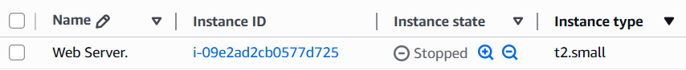***Figure 25: Change Instance type***

***Figure 26: Instance changed successfully***

***Figure 27: Stop protection configuration***

**Resize the EBS Volume**

43. With the Web Server instance still selected, choose the **Storage** tab, select the name of the Volume ID, then select the checkbox next to the volume that displays.

***Figure 28: Storage tab***

***Figure 29: Modify volume***

1. Change the size to: 10 **NOTE**: You may be restricted from creating Amazon EBS volumes larger than 10 GB in this lab.

***Figure 30: Size changed***

***Figure 31: Modify volume size***

**Start the Resized Instance**

You will now start the instance again, which will now have more memory and more disk space.

1. In left navigation pane, choose **Instances.**
2. A screenshot of a computer

   AI-generated content may be incorrect.Select the **Web Server** instance.

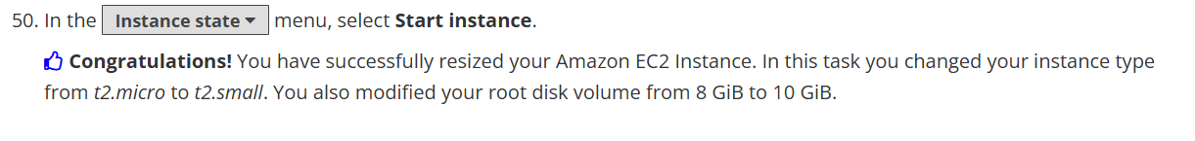***Figure 31: Start instance***

***Task 5: Explore EC2 Limits***

Amazon EC2 provides different resources that you can use. These resources include images, instances, volumes, and snapshots. When you create an AWS account, there are default limits on these resources on a per-region basis.

***Figure 32: Service Quotas Homepage***

52. Choose **AWS services** from the navigation menu and then in the AWS services Find services search bar, search for ec2 and choose **Amazon Elastic Compute Cloud (Amazon EC2).**

**Figure 33: Searching result**

***Figure 34: Criteria list***

**Task 6: Test Stop Protection**

You can stop your instance when you do not need to access but you would still like to retain it. In this task, you will learn how to use stop protection.

***Figure 35: EC2 Homepage***

***Figure 36: Choose instance to stop***

***Figure 37: Stop instance announcement***

**C. Submiiting My Work**

